QUESTION 1: extract file into SQL as CSV.

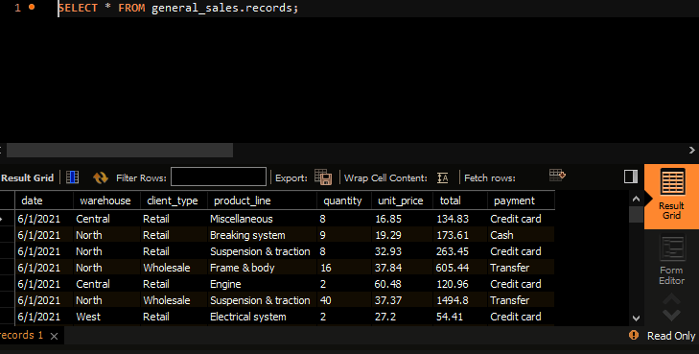

QUESTION 2. Find the total sales for each payments.

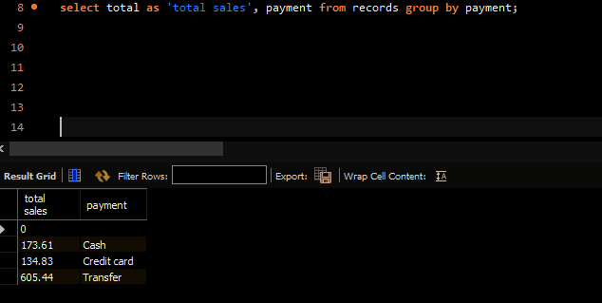

QESTION 3; what is the average unit price for each product?.

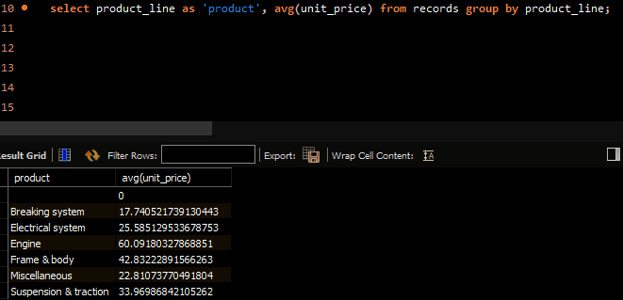

QESTION4; calculate the product with the higest sales?

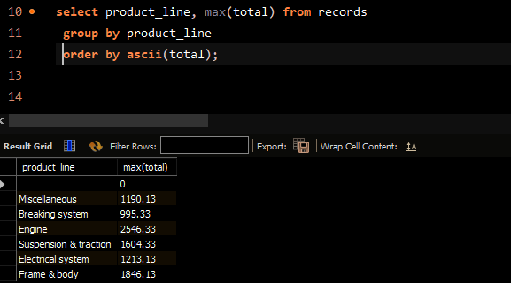

HIGHEST PRODUCT;

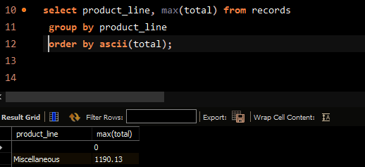

QUESTION5: total sales by product category?

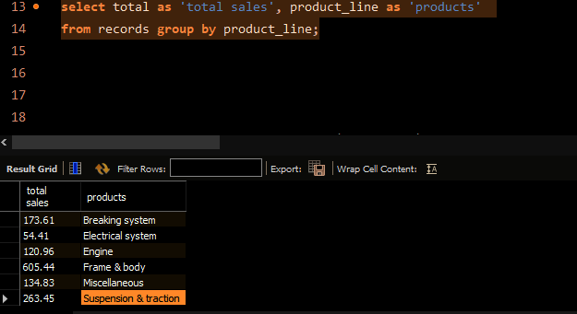

QUESTION6;Distinct retail warehouse?

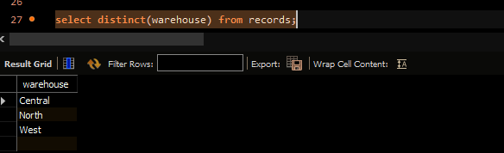

QUESTION7; Rank product line order by quantity?

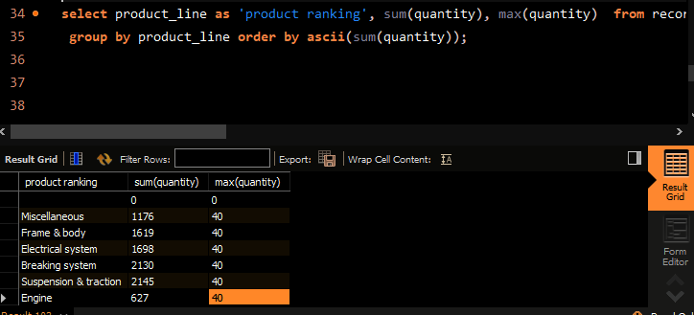

QUESTION8:Show the highest sales by client type?

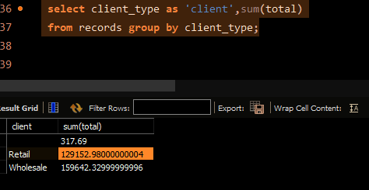

QUESTION9; show the date that has the highest sales?

